Preliminary Design Document and Options
Project: A-Plus Institute – Cluster 5
Prepared by: Leonardo Ciarcia, Assistant IT Manager, HV Technologies
Date: 12/08/2025
- Introduction
Two network options were considered for the A-Plus Institute upgrade. The design needs to support Brisbane’s expansion from three to five levels, connectivity with the separate Rookwood campus, and services for staff, students and guests.
Network Option 1 is the alternative proposal previously called Network 2. Network Option 2 is the selected final solution previously called Network 3.
- Network Option 1 – Alternative proposal
Option 1 uses a Cisco 2911 router and a main Cisco 2960 switch at each campus. Each router handles communication between VLANs through one shared trunk connection, an arrangement called router-on-a-stick.
Wireless access points are configured individually. The proposal includes a central Brisbane server for DHCP, DNS and files, with an encrypted VPN connecting the campuses through 3TTech.
Its main advantage is a simpler design with fewer devices and an expected lower initial equipment cost. Its limitations include dependence on a single main switch and router trunk at each campus, possible congestion on the shared trunk, and more manual wireless administration as the network grows.
Evidence 1 – Network Option 1
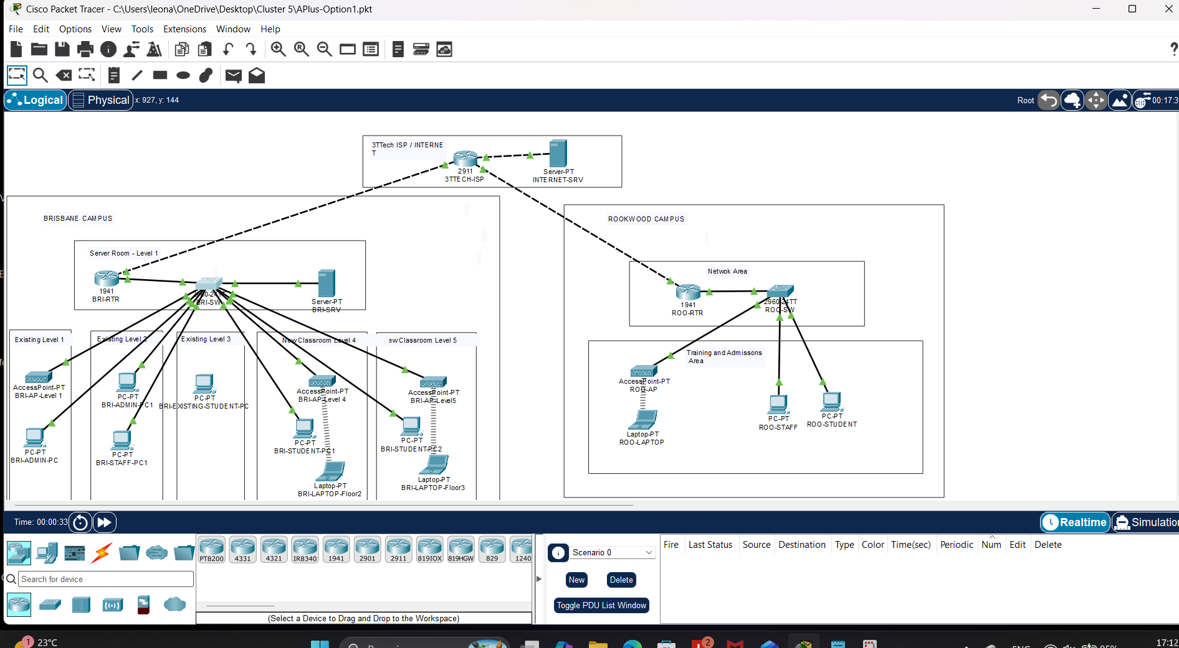
Figure 1: Alternative design showing both campuses, campus routers and switches, autonomous access points and the 3TTech connection.
- Network Option 2 – Selected final solution
Option 2 uses two Layer 3 core switches in Brisbane, with a separate access switch and managed access point for each of the five levels. Floor switches connect to both cores, providing alternate paths for selected link or core failures.
The Brisbane server room is located within Existing Level 1. It contains the server connections, NAS, monitoring-server representation and wireless controller.
Rookwood has its own Layer 3 core, administration/classroom access switches, local server, NAS and managed wireless equipment. Both campuses use VLAN segmentation and connect through the 3TTech site-to-site VPN.
This arrangement provides a clearer structure for expansion, local services at both campuses and central wireless management within each campus. It requires more equipment and configuration than Option 1.
Evidence 2 – Network Option 2
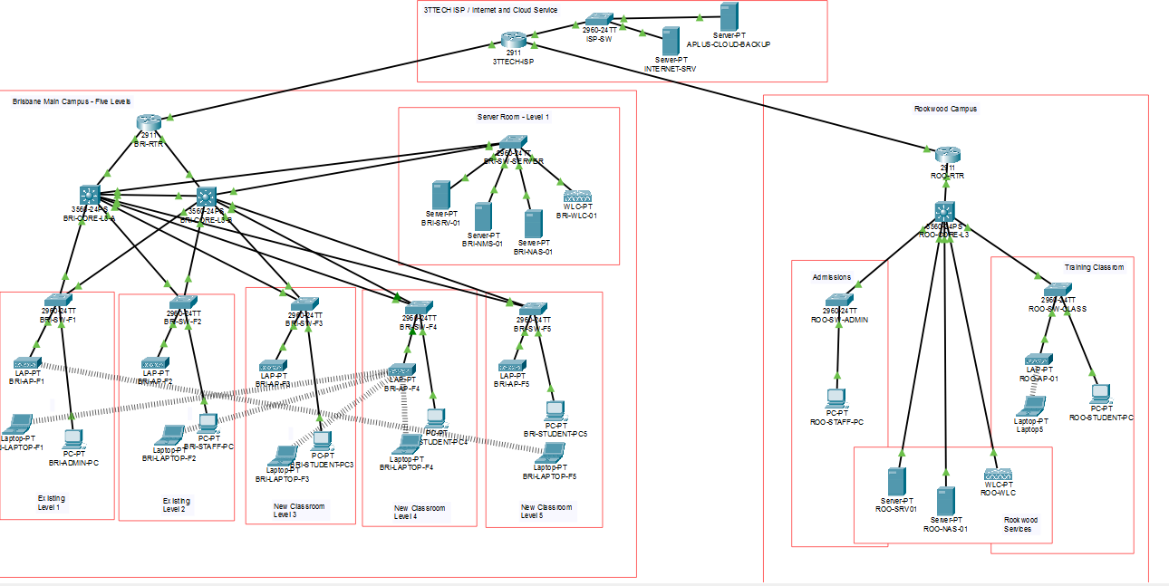
Figure 2: Selected design showing Brisbane’s five levels, two core switches, server room, managed wireless network and separate Rookwood campus.
- Comparison of options
Design feature | Network Option 1 | Network Option 2 – Final
Inter-VLAN routing | Campus routers handle VLAN routing over a shared trunk | Layer 3 core switches handle local VLAN routing
Brisbane switching | One main campus switch | Two core switches, five floor access switches and a server switch
Redundancy | Dependence on single main switches and router trunks | Alternate core and uplink paths in Brisbane
Wireless management | Access points configured individually | Wireless controllers manage campus access points
Server arrangement | Central Brisbane server; no local Rookwood server shown | Local servers and NAS resources at both campuses
Expansion | Growth increases reliance on the main switch and shared trunk | Separate floor/access groups provide a more flexible structure
Equipment and administration | Fewer devices; simpler initial setup | More devices and configuration; more centralised wireless administration
The expected cost difference is based on equipment requirements. Actual costs depend on the components list and vendor quotations.
- Selection decision
Network Option 2 was selected because it better supports the five-level Brisbane campus, Rookwood’s local service needs, wireless administration and future expansion. Its alternate Brisbane paths also reduce dependence on a single core switch or uplink.
The design still depends on individual campus routers, the single Rookwood core and the ISP service. These remaining risks are addressed in the contingency plan.
The diagrams provide evidence of the design options. Connectivity, performance and recovery results are documented separately in the test reports.

